**Homework 5**

**Submit: Blackboard/Paper Due: Dec. 13th 13:00**

**Please write down Your Name & Student ID**

1. Assuming that there are protons in a cubic centimeter of water, what is the magnetization contained within this volume at a magnetic field strength of 2 Tesla at room temperature (300K)?
2. Calculate the effects of the following pulse sequences on thermal equilibrium magnetization. The final answer should include x-, y-, and z-components of magnetization.

a) x (a pulse with tip angle , applied about the x-axis).

b) .

c) (the second pulse is applied immediately after the first).

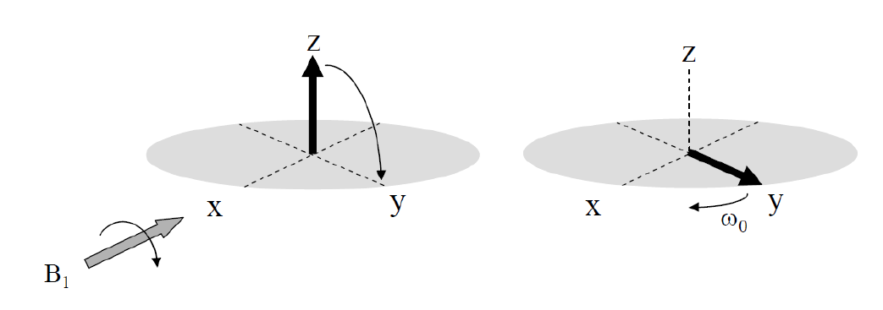

**Figure 2**

1. The operator wishes to acquire an oblique slice shown by the orientation of the white bar in Figure 3 (coronal plane). Draw the gradient echo imaging sequence that would be run to acquire such an image.

Figure 3

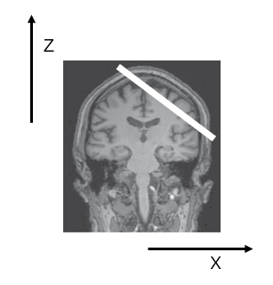

1. Derive the value of the Ernst angle given in Equation:
2. Choose the correct option from (a)-(e) and explain why this is your choice. The maximum MR signal is obtained by using:

(a) RF pulse, short TE, and long TR;

(b) RF pulse, short TE, and short TR;

(c) RF pulse, long TE, and short TR;

(d) RF pulse, short TE, and short TR;

(e) RF pulse, long TE, and short TR.

1. Choose the correct option from (a)-(e) and explain why this is your choice. Water in tendons is bound very strongly and cannot diffuse freely. It produces very low MR signal intensity because:

(a) T1 is too short;

(b) T2 is too short;

(c) T2* is very long;

(d) T2 is longer than T1;

(e) T2* is longer than T2.

1. Three images are shown in Figure 7: the scaling in each image is different and is normalized to the same maximum value. The imaging parameters for three images are (1) TR = 3000 ms, TE = 15 ms, (2) TR = 900 ms, TE = 60 ms (3) TR = 3000 ms, TE = 60 ms respectivly.

(i) Assign each image to the appropriate TR and TE values.

(ii) Given that the ventricles in the middle image is much brighter than in the right image, while the brain tissue is slightly brighter. Based on your answer, do the ventricles have a higher or lower T1 value than brain tissue? What is the corresponding answer for T2?

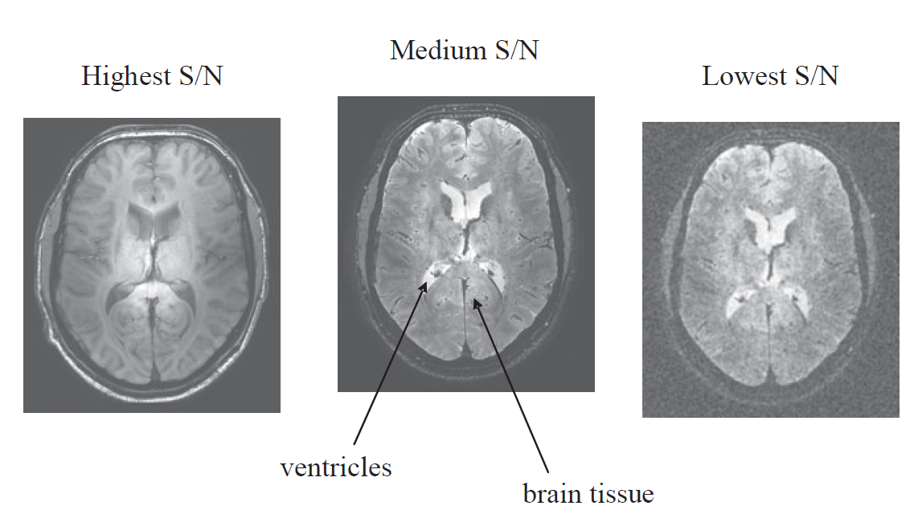

**Figure 7**

1. Consider the pulse sequence in Figure 8 (surface 2 equals two times surface 1). Draw the trajectory of k in the k-space. shown in Figure 8.

**Figure 8**

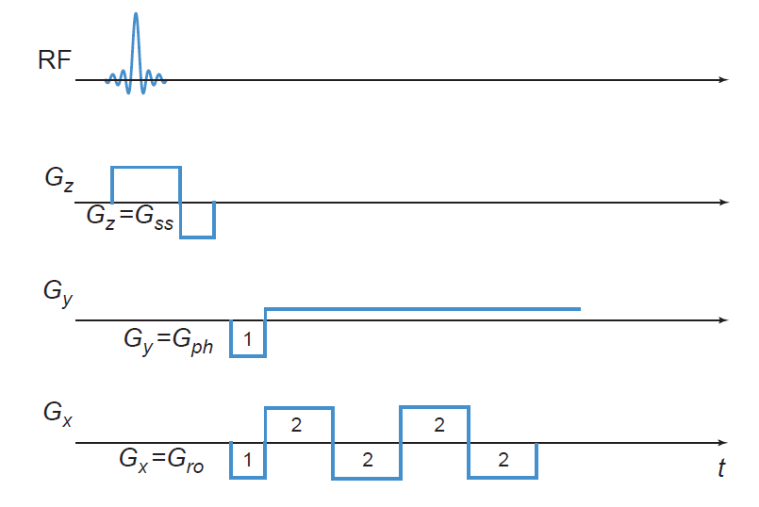

1. Sketch an EPI pulse sequence that gives the square spiral k-space trajectory shown in Figure 9. Assume that the height of the right triangle is always greater than the base.

**Figure 9**

